**Lab Report-04**

|  |  |
| --- | --- |
| **Course Code:** | **Course Title:** |
| CSE 416 | Web Engineering Lab |

|  |  |
| --- | --- |
| **Lab Report Details** | |
| Lab Perform Date | : 03/07/2025 |
| Report Submission Date | : 10/06/2025 |

|  |  |  |
| --- | --- | --- |
| **Submitted To** | **Submitted By** | |
| **Ms. Nishat Sadaf Lira**  Lecturer  Department of CSE  Daffodil International University. | Name  SID  Section  Daffodil | : Munna Biswas  : 221-15-5261  : 61-J2  International University |
|  | |

**Experiment No: 04**

**Experiment Name:** Database-Driven Web Application Development with PHP and MySQL.

**Objective:**

To develop a simple database-driven web application using PHP and MySQL that performs CRUD (Create, Read, Update, Delete) operations on a student records database.

**JavaScript Operations Performed:**

| **No.** | **Feature / Concept** | **Description** | **Example Functions / Syntax** |
| --- | --- | --- | --- |
| 1 | Basic PHP Syntax | Embedding PHP inside HTML, variables, and echo statements. | <?php ... ?>, $var |
| 2 | Database Connection | Connecting PHP to MySQL database using mysqli or PDO. | mysqli_connect() |
| 3 | Create Operation | Inserting new data into database tables. | INSERT INTO query |
| 4 | Read Operation | Fetching and displaying data from database. | SELECT query |
| 5 | Update Operation | Editing and updating existing records. | UPDATE query |
| 6 | Delete Operation | Removing records from database. | DELETE query |

**Code Snippets and Outcomes:**

**1. Basic PHP Syntax**

**Description:**PHP code is written inside <?php ... ?> tags and can be embedded into HTML.

**Code Snippet:**

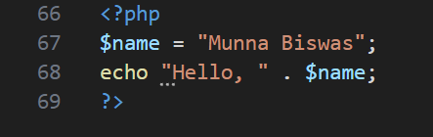

**Screenshot:**



**2. Database Connection**

**Description:**Connected PHP to MySQL using mysqli_connect().

**Code Snippet:**

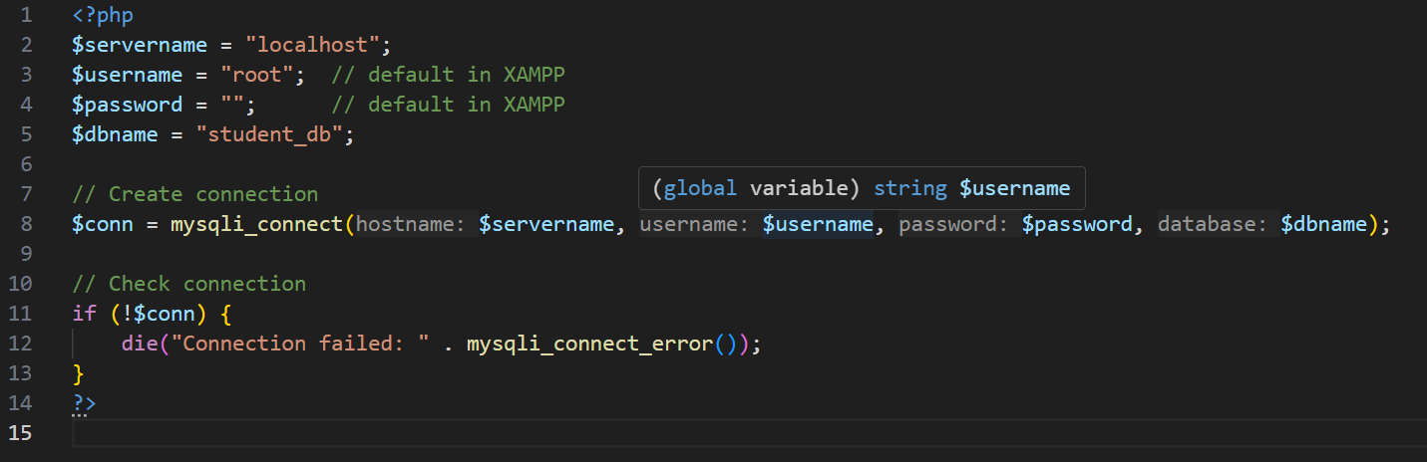

**Screenshot:**

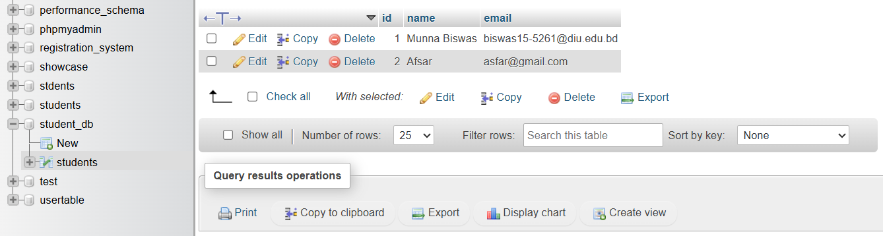

**3. Create Operation (Insert Data)**

**Description:**Inserted new student record into the database.

**Code Snippet:**

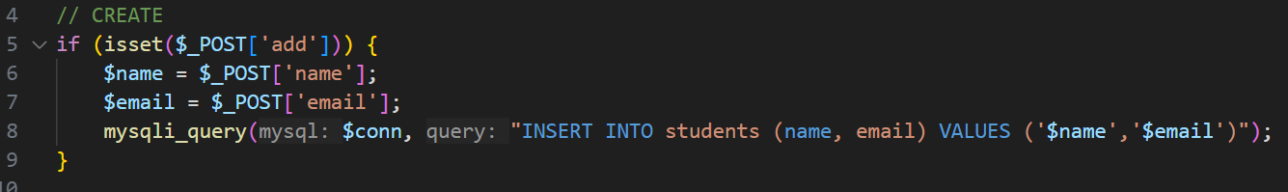

**Screenshot:**

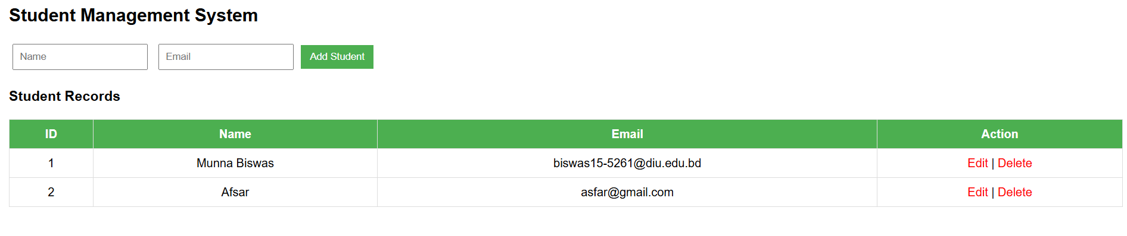



**4. Read Operation (Fetch Data)**

**Description:**Fetched and displayed student data in an HTML table.

**Code Snippet:**



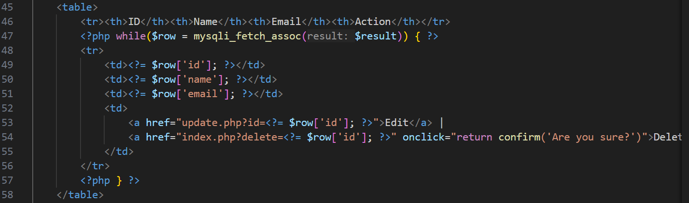

**Screenshot:**

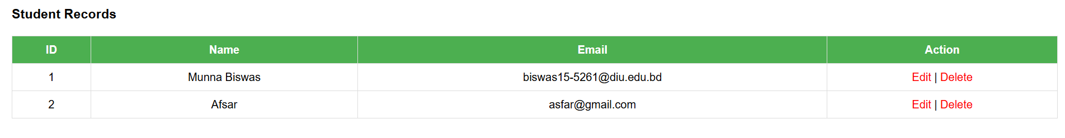

**5. Update Operation (Edit Data)**

**Description:**Updated an existing student’s email in the database.

**Code Snippet:**

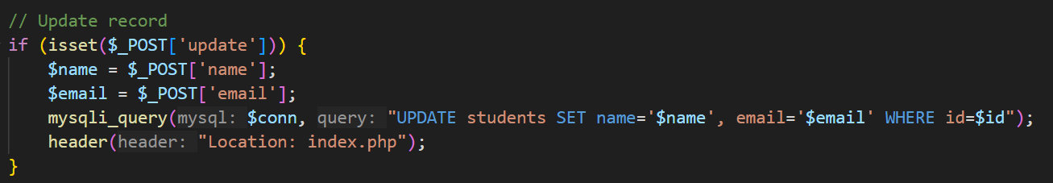

**Screenshots:**







**6. Delete Operation (Remove Data)**

**Description:**Deleted a student record from the database.

**Code Snippet:**

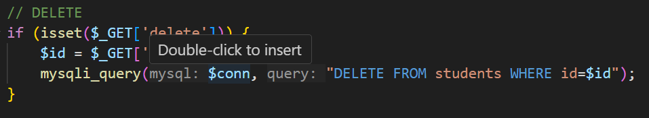

**Screenshot:**

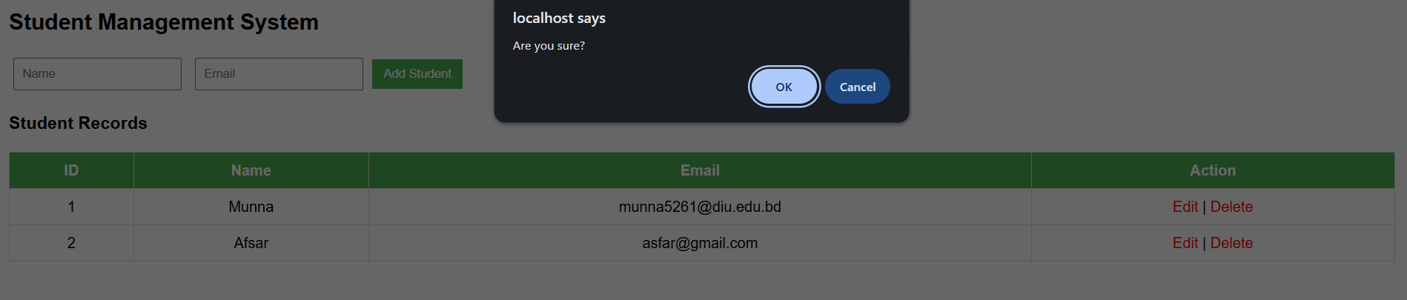

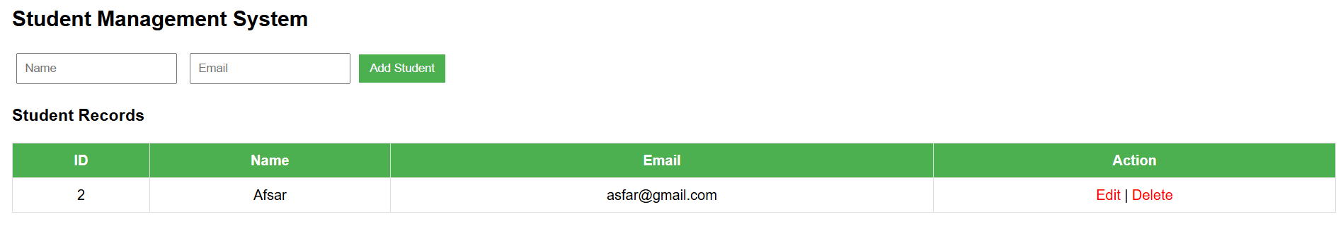



**Outcome:**

The student management application successfully performed CRUD operations. Users could add, view, update, and delete student records stored in a MySQL database.

**Conclusion:**

PHP and MySQL provide a powerful way to create dynamic, database-driven web applications. CRUD functionality is essential for almost all real-world applications such as student management, e-commerce, and content management systems.

**References:**

<https://www.php.net/manual/en/>

<https://www.w3schools.com/php/>

<https://www.mysqltutorial.org/>